StephazonU SRS Document

Stephanie Loper
The University of Arizona Global Campus
CST 499 Capstone for Computer Software Technology
Instructor: Joseph Rangitsch
09.16.2024

Software Requirements Specification
for
StephazonU
Version 1.0 approved
Prepared by Stephanie Loper
Stephazon School of World Domination: A Stephazon Company
09.16.2024
Table of Contents
Table of Contents ii
Revision History iii
1. Introduction 1
1.1 Purpose 1
1.2 Document Conventions 1
1.3 Intended Audience and Reading Suggestions 1
1.4 Project Scope 2
1.5 References 2
2. Overall Description 2
2.1 Product Perspective 2
2.2 Product Features 3
2.3 User Classes and Characteristics 3
2.4 Operating Environment 4
2.5 Design and Implementation Constraints 4
2.6 User Documentation 4
2.7 Assumptions and Dependencies 4
3. System Features 5
3.1 User Registration and Login 5
3.1.1 Functional Requirements 5
3.1.2 Stimulus/Response Sequences 5
3.2 Profile Management 5
3.2.1 Functional Requirements 5
3.2.2 Stimulus/Response Sequences 5
3.3 Course Enrollment 6
3.3.1 Functional Requirements 6
3.3.2 Stimulus/Response Sequences 6
4. External Interface Requirements 6
4.1 User Interfaces 6
4.2 Hardware Interfaces 6
4.3 Software Interfaces 7
4.4 Communications Interfaces 7
5. Other Nonfunctional Requirements 7
5.1 Performance Requirements 7
5.2 Safety Requirements 7
5.3 Security Requirements 7
5.4 Software Quality Attributes 8
6. Other Requirements 8
Appendix A: Glossary 9
• Admin Facing: Documentation and training for administrators managing courses, enrollment, and user privacy. 9
• Backend Database: The system storing user data, course information, and waitlist details. 9
• bcrypt: A secure hashing algorithm used for safely storing passwords. 9
• Concurrent Access: The system's ability to support multiple users simultaneously. 9
• Encryption: Securing data through protocols like TLS and HTTPS to prevent unauthorized access. 9
• External Interface Requirement (EIR): Specifications describing the system’s interaction with external components. 9
• Functional Requirement (FR): The specific behaviors or functionalities the system must support (e.g., registration). 9
• Internationalization (I18N): The system’s ability to support multiple languages and regions. 9
• Non-functional Requirement (NFR): Describes system attributes like security, performance, and scalability. 9
• Profile Management: Features allowing users to create and update personal information. 9
• Real-time Data: Constantly updated information, such as enrollment status and waitlists. 9
• Reliability: System availability, ensuring 99.9% uptime with minimal downtime. 9
• Scalability: The system’s capacity to efficiently handle growth in users or data. 9
• Service Level Objective (SLO): A measurable target for system performance (e.g., uptime). 9
• TLS (Transport Layer Security): A protocol for securing data between the browser and server. 9
• User Facing: Documentation and tutorials for students on registration, profile management, and course enrollment. 9
Appendix B: Analysis Models 10

Revision History
Name | Date | Reason For Changes | Version
Stephanie Loper | 09.16.24 | Development of Document | 1

Introduction

Purpose
The purpose of this SRS document is create a robust and through definition of the requirements for an online course management system for the Stephazon School of World Domination. This system will be named StephazonU and will serve as the centralized platform for the administration of course offerings, student registration, and course enrollment management for the university. By clearly defining the primary functionalities of this system, this document will serve as a clear guide for the development and implementation of the system.

Document Conventions
- Functional requirements are tagged as FR-#.
- Non-functional requirements are tagged as NFR-#.
- External interface requirements are tagged as EIR-#.
- Each requirement will have a priority level labeled as follows:
  - P1: High priority
  - P2: Medium priority
  - P3: Low priority

Intended Audience and Reading Suggestions
- Developers: Should primarily focus on System Features and Functional Requirements. They are the intended audience of the more technical specifications as well as the design constraints.
- Testers: Should focus on Stimulus/Response Sequences and Functional Requirements. They should validate the system behavior against the intended requirements. Sections that are recommended for testers the sections include System Features, Functional Requirements, and any Stimulus/Response Sequences.
- Project Managers: Should focus on the Overall Description and Design Constraints. They will need to understand the product scope as well as the key limitations. They are the intended audience of the more managerial aspects of the requirements such as the project scope and constraints.

Project Scope
StephazonU must allow new user registration with unique IDs and passwords, prevent duplicate registrations, include profile details such as name, phone, and email, enable login post-registration, offer courses across three semesters (spring, summer, fall) with varying enrollment limits, manage waitlists for full courses, and notify waitlisted users when a spot becomes available after an enrolled user cancels.

References
Das, S. (2023, April 6). How fast should a website load in 2023?. BrowserStack. https://www.browserstack.com/guide/how-fast-should-a-website-load
Principles. ICO. (n.d.). https://ico.org.uk/for-organisations/intelligence-services-processing/principles/
Sumner, S., Leavitt, S., & Siemens, C. (2024, August 20). Recommendations for defining reliability targets - microsoft azure well-architected framework. Microsoft Azure Well-Architected Framework | Microsoft Learn. https://learn.microsoft.com/en-us/azure/well-architected/reliability/metrics

Overall Description

Product Perspective
StephazonU is a standalone web application designed to manage course enrollment, course availability, and user registrations for a university or educational platform. It will interface with a backend database to manage user data and course information.
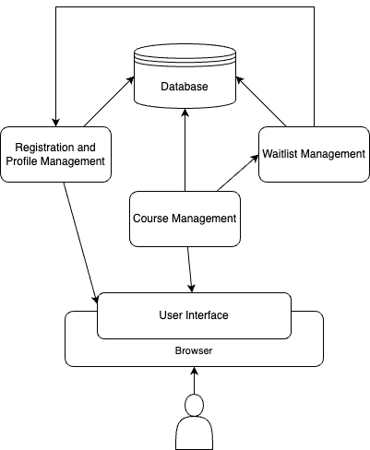

Product Features
- New user registration with unique ID and password. Duplicate IDs must be prevented.
- User profiles must include name, phone, email, and other relevant information.
- Users can log in with their ID and password after registration.
- Courses are offered in three semesters per year (spring, summer, fall). Not all courses are available every semester.
- Each course has a maximum enrollment limit, which may vary by course.
- If a course is full, users can join a waiting list.
- Users can cancel course enrollment, and the first user on the waitlist is notified to enroll.

User Classes and Characteristics
- Students: These are the users who register, create profiles, and enroll in courses.
- Administrators: These are the users who manage course offerings and view enrollment status.
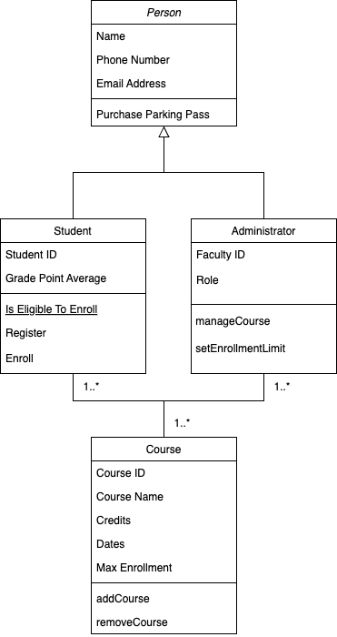

Operating Environment
- StephazonU is a browser-based application, meaning it should be able to be accessed from any modern web browser other than Internet Explorer.
- Since StephazonU is browser-based, it should work across various operating systems and devices, including desktops, laptops, tablets, and mobile phones and operating systems such as Windows, macOS, and mobile operating systems (Android, iOS) provided there is internet access and a compatible browse

Design and Implementation Constraints
- Security protocols must be followed for password encryption and sensitive data management.
- The system should allow scalability to accommodate multiple courses and large numbers of users.
- Course scheduling, enrollment, and waitlist management must depend on real-time data from the backend database as information must be as accurate as is possible.

User Documentation
- Student Facing - User guides and video tutorials will be provided to student users on how to register, create profiles, enroll in courses, join waitlists, and cancel enrollments.
- Admin Facing - Detailed on the job training and documentation will be provided to administrative users on managing course offerings, enrollment limits, and privacy surrounding user data.

Assumptions and Dependencies
- StephazonU assumes the user has access to a reliable internet connection.
- StephazonU assumes that the backend database is correctly configured and provides accurate and timely data.
- StephazonU assumes the users have a minimum level of computer understanding to create accounts and navigate a web-based application.
- StephazonU depends on third-party libraries for user authentication and data security.

System Features

User Registration and Login

Functional Requirements
- FR-1 [P1]: StephazonU must allow new users to create a unique ID with a password.
- FR-2 [P1]: StephazonU must validate that the ID is unique before registration is completed.
- FR-3 [P1]: StephazonU must encrypt passwords for storage.
- FR-4 [P1]: Users must be able to log in using their ID and password.

Stimulus/Response Sequences
- Stimulus: User submits registration form.
- Response: StephazonU checks for unique ID and stores profile if valid.
- Stimulus: User submits login form.
- Response: StephazonU authenticates credentials and grants access if valid and notifies if log in fails.

Profile Management

Functional Requirements
- FR-5 [P1]: The StephazonU system must utilize the database to store user profile data, including name, phone, and email.
- FR-6 [P2]: StephazonU must allow users to update their profiles post-registration.

Stimulus/Response Sequences
- Stimulus: User completes profile form.
- Response: The system saves the profile information to the database so that it is accessible on subsequent login sessions.

Course Enrollment

Functional Requirements
- FR-7 [P1]: StephazonU must allow Student users to view available courses for the current semester.
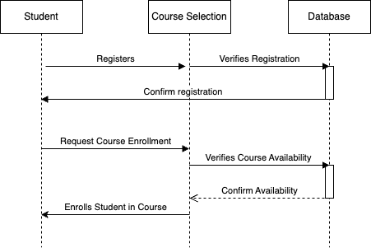
- FR-8 [P1]: The StephazonU system must track course enrollment limits.
- FR-9 [P2]: StephazonU must allow users to join a waitlist if the course is full.
- FR-10 [P2]: StephazonU must notify the next user on the waitlist when a spot becomes available.
- FR-11 [P2]: StephazonU must allow users to cancel their enrollment.
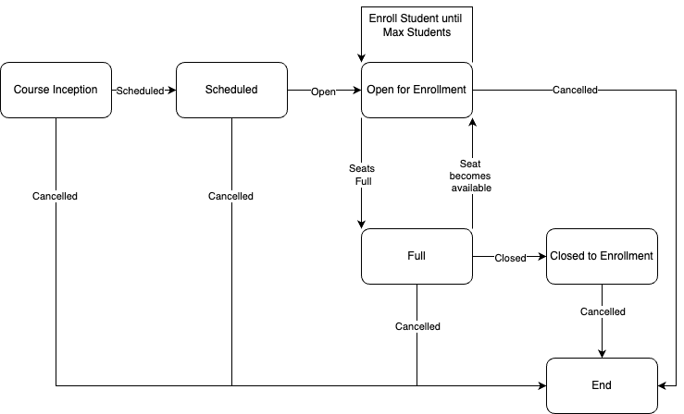

Stimulus/Response Sequences
- Stimulus: The student user selects a course to enroll in.
- Response: The system checks the course capacity and enrolls the user or places them on a waitlist depending on the availability.
- Stimulus: Student users cancels enrollment in a course.
- Response: StephazonU updates the enrollment status and checks to see if there is another student user on the waitlist; if so, it will notify them.

External Interface Requirements

User Interfaces
- EIR-1 [P1]: StephazonU must provide a web-based user interface for registration, profile management, course enrollment, and waitlist management.

Hardware Interfaces
- EIR-2 [P3]: As StephazonU is web-based, no specialized hardware interface is required. The system should work on standard user devices like desktops, laptops, tablets, and smartphones.

Software Interfaces
- EIR-3 [P1]: The StephazonU system must connect and query the backend database to store user and course information.

Communications Interfaces
- EIR-4 [P1]: StephazonU must use HTTPS protocol for secure communication between the user’s browser and the server to meet security requirements.

Other Nonfunctional Requirements

Performance Requirements
- NFR-1 [P1]: As StephazonU is a platform for all Stephazon School of World Domination students, the system must support concurrent access by multiple users.
- NFR-2 [P2]: Pages should load in less than 3 seconds under normal traffic conditions as “statistics indicate that 40% of visitors will leave a website if it takes longer than three seconds to load”(Das, 2023)

Safety Requirements
- NFR-3 [P1]: The StephazonU system must comply with data protection standards such as processing personal data lawfully, collecting it for specific purposes, and ensuring appropriate security to prevent unauthorized access (ICO., n.d.)

Security Requirements
- NFR-4 [P1]: The StephazonU system must use encrypted protocols such as TLS, HTTPS or SSH for login and data transmission.
- NFR-5 [P1]: User passwords must be stored using secure hashing algorithms. Bcyrpt will likely be used as the hashing algorithm of choice as it is often built into programming languages such as PHP.

Software Quality Attributes
- NFR-6 [P1]: The system should be reliable and available 99.9% of the time as this will result in “8.76 hours of non-compliance per year”(Sumner et al., 2024), which is a reasonable target for an educational platform like StephazonU.
- NFR-7 [P2]: The StephazonU system should be consistently maintainable to support ever-changing course offerings and enrollment capacities.

Other Requirements
- NFR-8 [P3]: Internationalization requirements for users from different regions is key as the Stephazon School of World Domination is global in nature.
- NFR-9 [P1]: Legal compliance with educational data protection regulations is required in all operating regions of the StephazonU system.
Appendix A: Glossary
- Admin Facing: Documentation and training for administrators managing courses, enrollment, and user privacy.
- Backend Database: The system storing user data, course information, and waitlist details.
- bcrypt: A secure hashing algorithm used for safely storing passwords.
- Concurrent Access: The system's ability to support multiple users simultaneously.
- Encryption: Securing data through protocols like TLS and HTTPS to prevent unauthorized access.
- External Interface Requirement (EIR): Specifications describing the system’s interaction with external components.
- Functional Requirement (FR): The specific behaviors or functionalities the system must support (e.g., registration).
- Internationalization (I18N): The system’s ability to support multiple languages and regions.
- Non-functional Requirement (NFR): Describes system attributes like security, performance, and scalability.
- Profile Management: Features allowing users to create and update personal information.
- Real-time Data: Constantly updated information, such as enrollment status and waitlists.
- Reliability: System availability, ensuring 99.9% uptime with minimal downtime.
- Scalability: The system’s capacity to efficiently handle growth in users or data.
- Service Level Objective (SLO): A measurable target for system performance (e.g., uptime).
- TLS (Transport Layer Security): A protocol for securing data between the browser and server.
- User Facing: Documentation and tutorials for students on registration, profile management, and course enrollment.
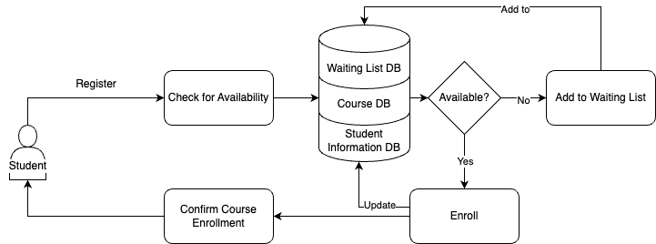
Appendix B: Analysis Models
Figure 1: Enrollment Activity Diagram
Figure 2: Class Diagram
Figure 3: Sequence Diagram

Figure 4: State Diagram for Course

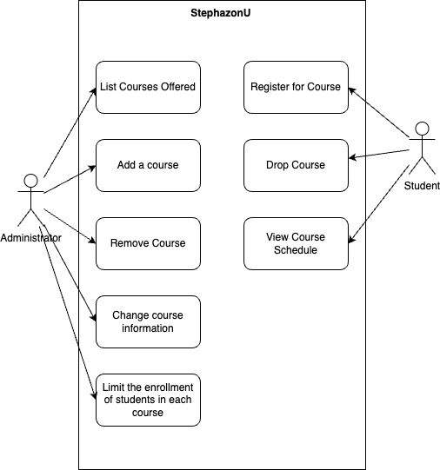
Figure 5: UseCase Diagram
References:
Das, S. (2023, April 6). How fast should a website load in 2023?. BrowserStack. https://www.browserstack.com/guide/how-fast-should-a-website-load
Principles. ICO. (n.d.). https://ico.org.uk/for-organisations/intelligence-services-processing/principles/
Sumner, S., Leavitt, S., & Siemens, C. (2024, August 20). Recommendations for defining reliability targets - microsoft azure well-architected framework. Microsoft Azure Well-Architected Framework | Microsoft Learn. https://learn.microsoft.com/en-us/azure/well-architected/reliability/metrics
Tsui, F., Karam, O., & Bernal, B. (2018). Essentials of software engineering (4th ed.). Jones & Bartlett Learning.
Exinfm. (n.d.). Software requirement specifications for <project>Links to an external site. [Template]. https://exinfm.com/training/M2C3/srs_template.doc
Github Profile: https://github.com/Stevie-Evie
